1. var is a function scope , its hosted on the top of it

console.log(a);

var a = 10;

console.log(a); // 10

2. function scope , global socpe

3. number : var x =5 ;

string : var name = "mostafa";

null , undifiend ,

boolean : var flag = true ;

4. primitive type : stored by value

var a = 100;

var b = a;

b = 200;

console.log(a);//100

console.log(b);//200

objective type : stored by reference

var obj1 = { value: 100 };

var obj2 = obj1;

obj2.value = 200;

console.log(obj1.value); // 200

console.log(obj2.value); //200

5. var numLiteral = 42;

var numObject = new Number(42);

console.log(typeof numLiteral);

console.log(typeof numObject);

// String

var strLiteral = "hello"; // literal

var strObject = new String("hello"); // constructor

console.log(typeof strLiteral); // "string"

console.log(typeof strObject); // "object"

// Boolean

var boolLiteral = true; // literal

var boolObject = new Boolean(true); // constructor

console.log(typeof boolLiteral); // "boolean"

console.log(typeof boolObject); // "object"

6- use literals safe, simple, and predictable . Constructors are rarely needed.

7- console.log(x.toFixed(2)); -> 123.46 formats the number with 2 digits after the decimal point

console.log(x.toPrecision(4)); ->123.5 formats the number with 4 significant digits total

8- NaN stand for not a number , check it with .isNaN() function ,

var a = 0/0 ;

console.log(isNaN(a));

9- parseInt() -> Converts a string to an **integer** :

parseInt("42.5") the output will be 42 because it convert to integer

parseFloat() -> Converts a string to an Float:

parseFloat ("42.5") -> the output will be 42.5 because it convert to float

Number()-> convert the string to number integer or float

Number(“42”) -> 42

Number(“42.5”)-> 42.5

10- implicit casting -> java script autmaticaly convert type to another when needed :

Var x = “5” +2 ; casting the number into string

Explicit casting -> manualy convert type to another

Var x = Number(“5”) +2 ;

11- - true + 5 =6

- "10" – 2 =8

- 12 - "1a" -> NAN

- 5 / 0 -> Infinity

- 5 + undefined -> NAN

12- 15.5 'number'   
var a = "15.5"; assign 15.5 as integer to a

var b = +a; assign a to b after convert it to integer a cause of +

now b assign to 15.5 as a number

13- true . it’s compare evfery two side of the comparing operator first and so

20 > true then true <5 then true ==1

true true true

14 - 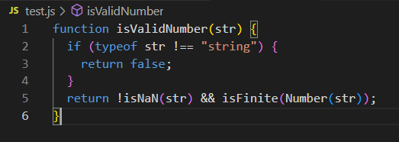

15- 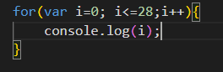 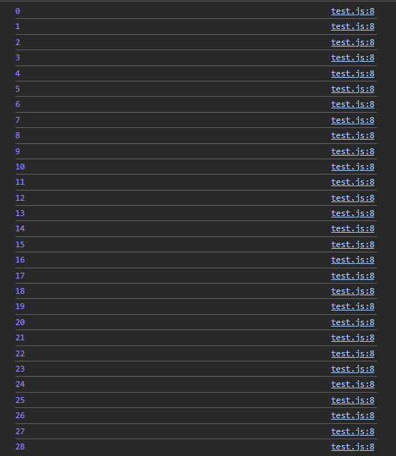

16- 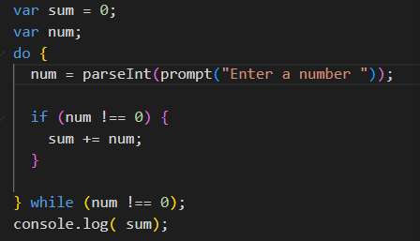

17- 